Рифмовки, стихи и песни на английском языке для учеников начальных классов
Составила: Чуйкова Т.Д.

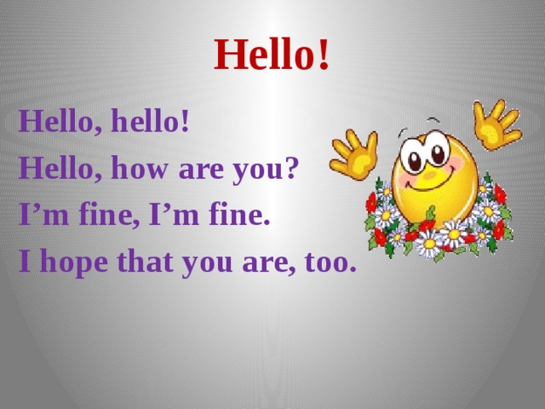

Hello!
Hello, hello!
Hello, how are you?
I’m fine, I’m fine.
I hope that you are, too.
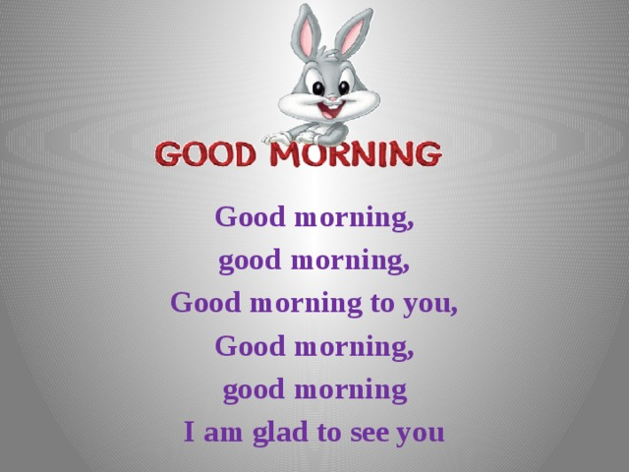

Good morning,
good morning,
Good morning to you,
Good morning,
good morning
I am glad to see you
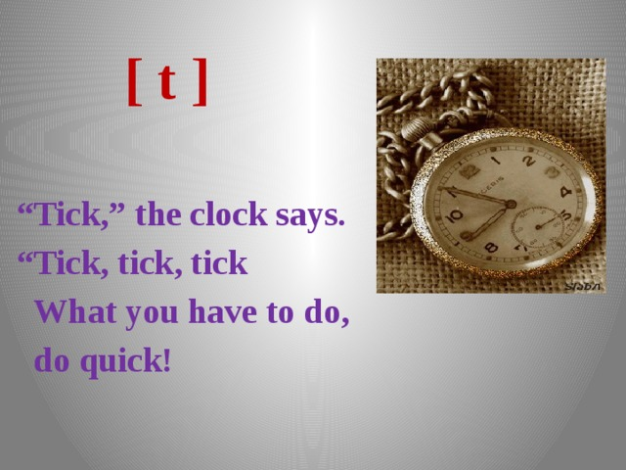
[ t ]
“ Tick,” the clock says.
“ Tick, tick, tick
What you have to do,
do quick!
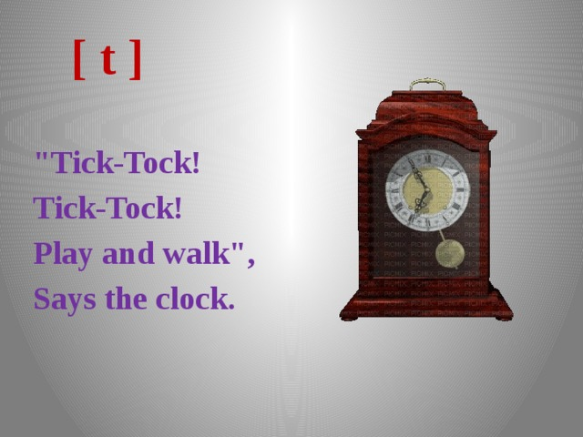
[ t ]
"Tick-Tock!
Tick-Tock!
Play and walk",
Says the clock.
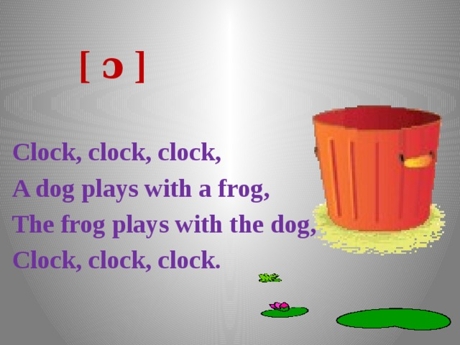
[ ɔ ]
Clock, clock, clock,
A dog plays with a frog,
The frog plays with the dog,
Clock, clock, clock.
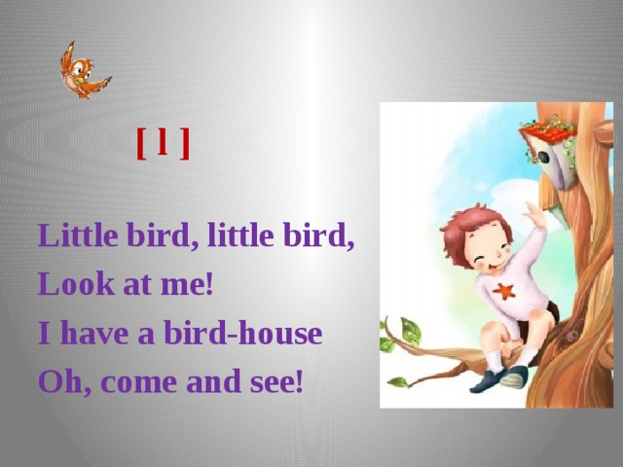
[ l ]
Little bird, little bird,
Look at me!
I have a bird-house
Oh, come and see!
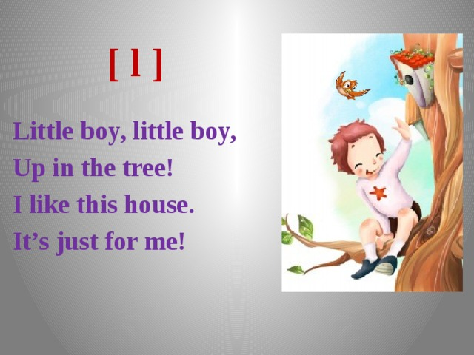
[ l ]
Little boy, little boy,
Up in the tree!
I like this house.
It’s just for me!
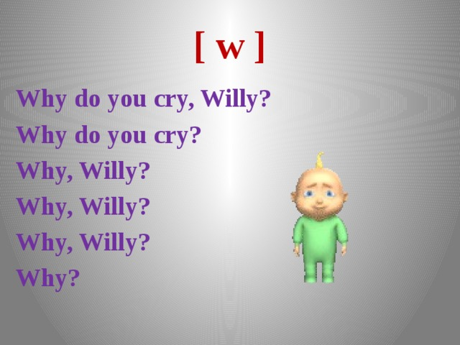
[ w ]
Why do you cry, Willy?
Why do you cry?
Why, Willy?
Why, Willy?
Why, Willy?
Why?
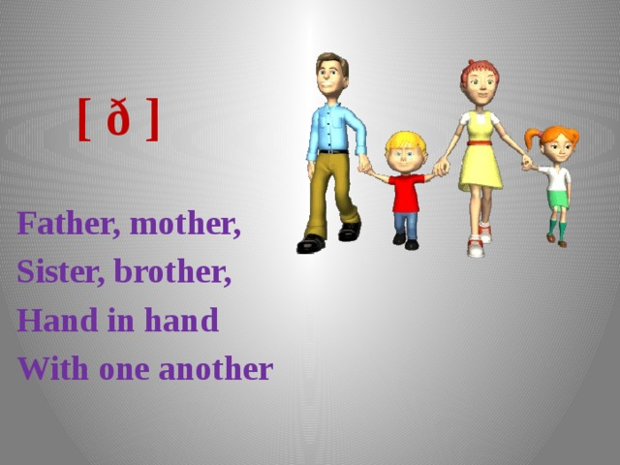
[ ð ]
Father, mother,
Sister, brother,
Hand in hand
With one another
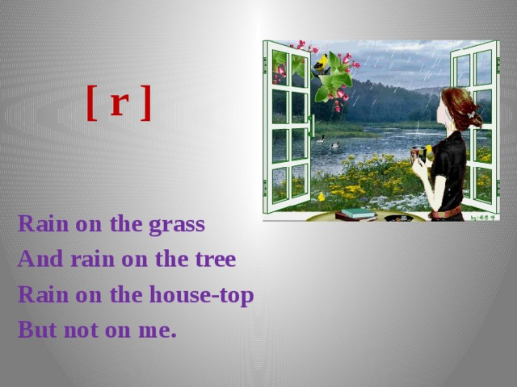
[ r ]
Rain on the grass
And rain on the tree
Rain on the house-top
But not on me.
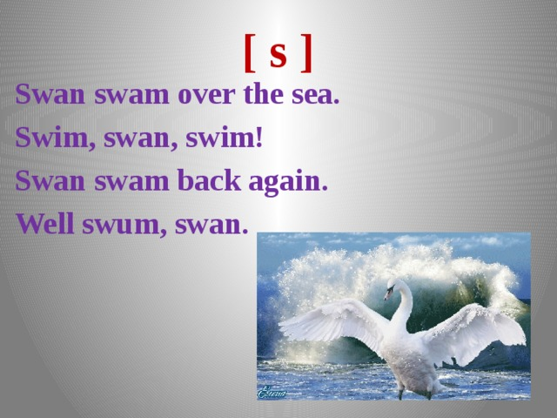
[ s ]
Swan swam over the sea.
Swim, swan, swim!
Swan swam back again.
Well swum, swan.
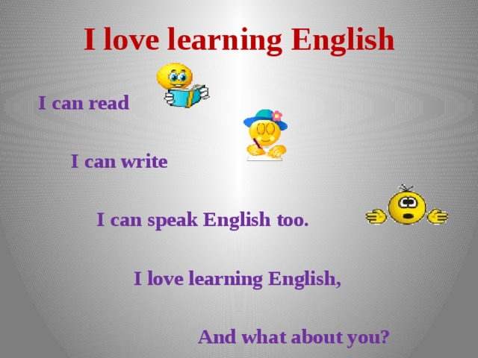
I love learning English
I can read
I can write
I can speak English too.
I love learning English,
And what about you?
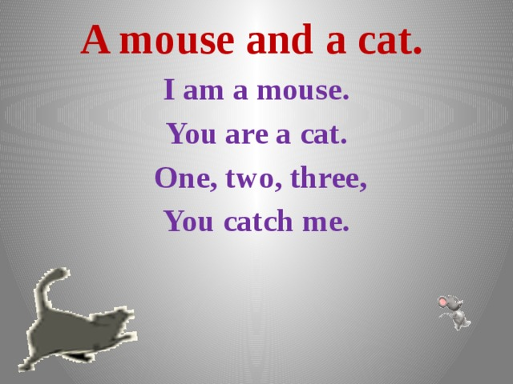
A mouse and a cat.
I am a mouse.
You are a cat.
One, two, three,
You catch me.
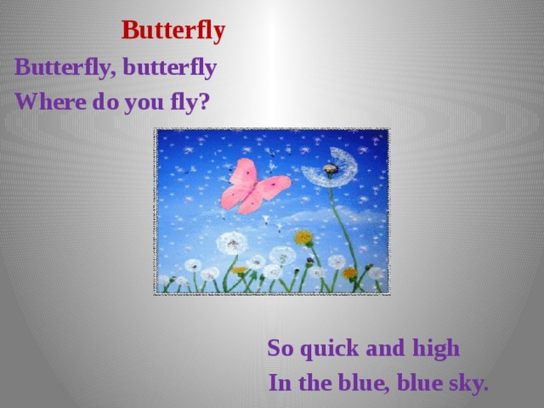
Butterfly
Butterfly, butterfly
Where do you fly?
So quick and high
In the blue, blue sky.
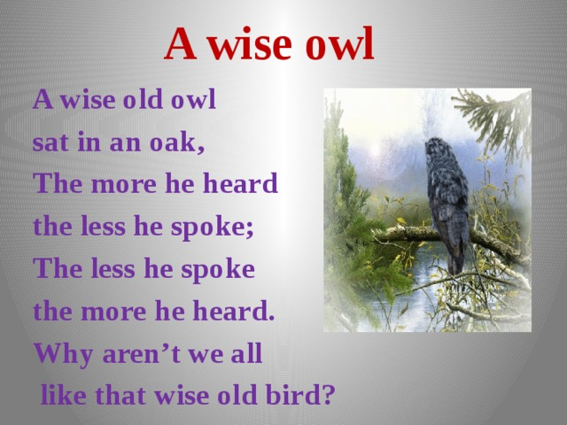
A wise owl
A wise old owl
sat in an oak,
The more he heard
the less he spoke;
The less he spoke
the more he heard.
Why aren’t we all
like that wise old bird?
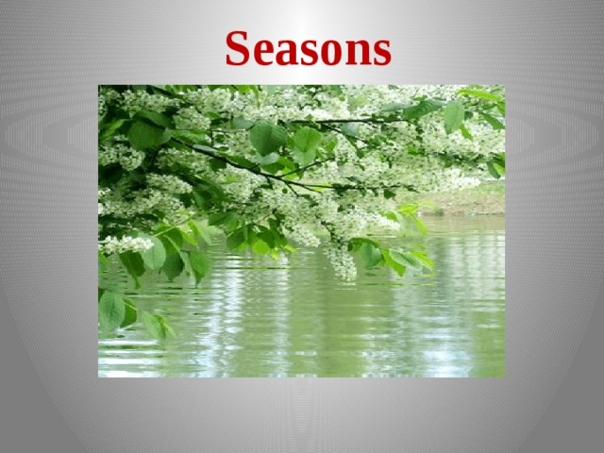
Seasons
Spring is green,
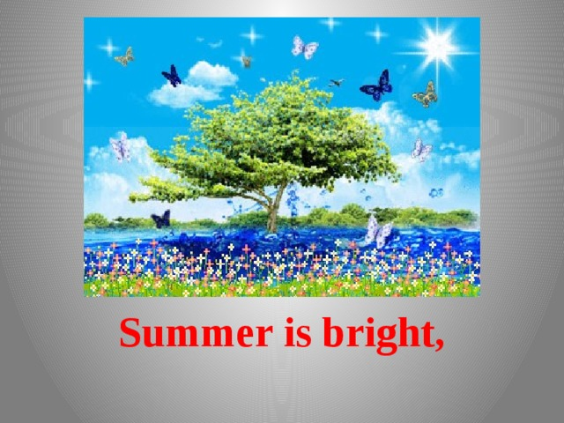
Summer is bright,
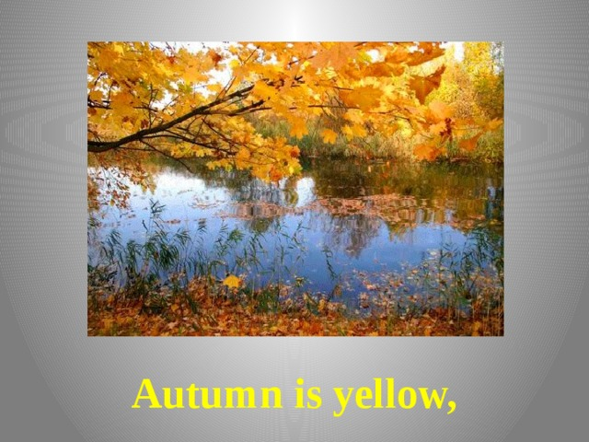
Autumn is yellow,
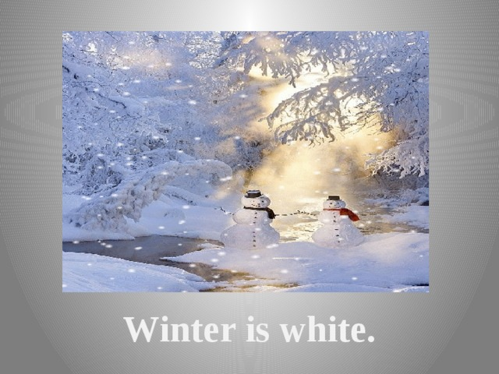
Winter is white.
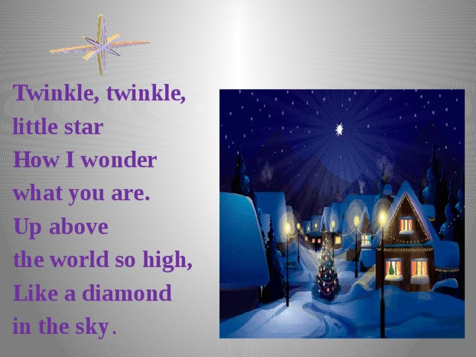
Twinkle, twinkle,
little star
How I wonder
what you are.
Up above
the world so high,
Like a diamond
in the sky .
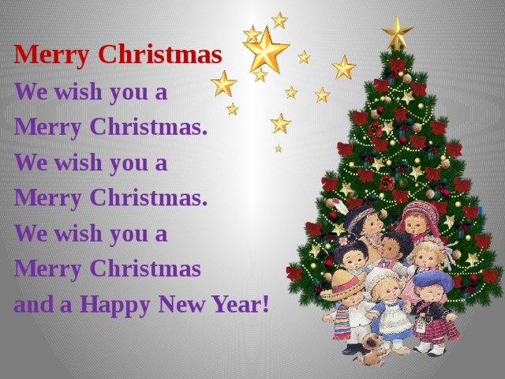
Merry Christmas
We wish you a
Merry Christmas.
We wish you a
Merry Christmas.
We wish you a
Merry Christmas
and a Happy New Year!
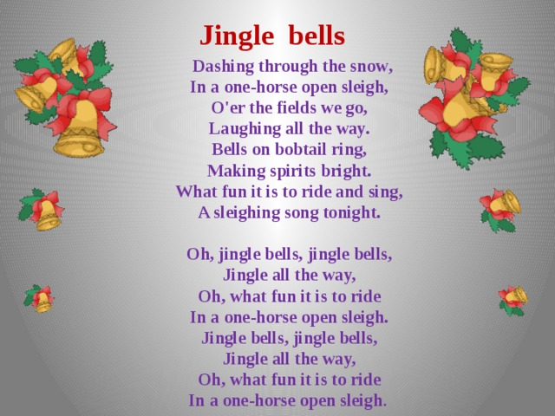
Jingle bells
Dashing through the snow , In a one-horse open sleigh, O'er the fields we go, Laughing all the way. Bells on bobtail ring, Making spirits bright. What fun it is to ride and sing, A sleighing song tonight. Oh, jingle bells, jingle bells, Jingle all the way, Oh, what fun it is to ride In a one-horse open sleigh. Jingle bells, jingle bells, Jingle all the way, Oh, what fun it is to ride In a one-horse open sleigh .



